Metadata – Land Degradation Analysis (Saudi Arabia, 2025)
Part 1: Basic Metadata (Mandatory)

1.01 Thumbnail
Prepare small thumbnail that represents this dataset. Create and save thumbnail. Insert thumbnail in the space provided and indicate the file name.
Create and save thumbnail | Enter file name
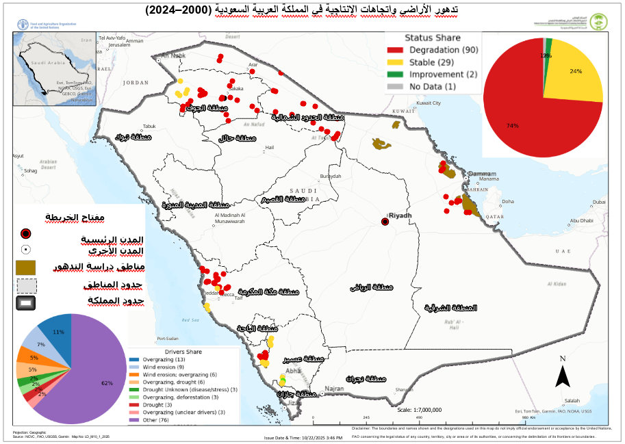

1.02 – Title
Descriptive title for this data. Should provide sufficient information to external users.
Enter Data Title
Land Degradation and Productivity Trends in Saudi Arabia (2000–2024)

1.03 – Abstract
Provide a short and concise abstract which summarizes what this data is about. Similar to the abstracted provided in a scientific paper.
Enter data abstract
This dataset presents field observations collected from targeted governorates across Saudi Arabia under the FAO–NCVC collaboration. A total of 120 geo-referenced points were surveyed between June and October 2022 to assess vegetation condition, soil degradation, and land productivity trends.
The sites were selected based on the land degradation status identified in Trends.Earth, taking into account the three subcomponents (land cover, land productivity, and carbon stock) using the baseline period (2000–2015) and the reporting period (2016–2020) for analysis. The regions were strategically selected to represent key ecological and administrative zones of interest to the FAO–NCVC Land Degradation Assessment Programme. Therefore, the data should be interpreted as indicative of local field conditions within sampled areas, rather than a comprehensive representation of the entire country.
Each observation includes detailed notes on vegetation health, soil texture, degradation type, and supporting photographs for satellite validation. The dataset complements national-scale remote sensing analyses by providing reliable ground-truth data for verification and calibration.

1.04 – Date type
Provide all three type of dates - Creation date, Publication date, and Revision date.
Identification of when a given event occurred
Creation | 2022
Publication | 2023
Revision | 2025
relevant date | 2025

1.05 – Group
The group, department or unit to which this data belongs.
Enter group name
Registered Members,
FAO Spatial Data Group,
Natural Resources Management Component NRM - FAO KSA

1.06 – Category  Provide one primary category to which this data belong. Select from the list provided. Possible categories related to the SRADP project are highlighted in green color. | 1.07 – Free-text Keywords  Keywords helps Search Engines such as Google find data requested by users. Use FAO AGRIS to select the most appropriate keywords for this data. To make the data discoverable, provide a minimum of 5 keywords.
Field declared Mandatory by the Metadata Schema | A space or comma-separated list of keywords. Use the  Widget to select from Hierarchical tree.
Select one of the following : (highlighted by Yellow) | REQUIRED: Common-use word or phrase used to describe the subject of the data set. (Provide 5 keyword minimum) (Land Degradation Assessment – Saudi Arabia; Drivers of Land Degradation; Sustainable Land Management (SLM) Interventions; Site Selection Using Global Datasets)
Imagery Base Maps Earth Cover | Field survey
Society | Saudi Arabia
Economy | Vegetation
Utilities Communication | Land degradation
Environment | Soil condition
Oceans | NDVI
Biota | validation
Health | Ground
Elevation | truthing
Geoscientific Information | NCVC
Planning Cadastre | FAO
Inland Waters | Natural
Boundaries | resources
Structure | Remote
Transportation | sensing
Intelligence Military
Location
Climatology Meteorology Atmosphere
Farming
Population | -

Part 2: Location and Licenses (Mandatory)

2.01 Language
Provide data language
Language used within the dataset
Enter data language
English

2.02 License
Provide the type of license under which this data is published and intended to be used.
License of the Dataset
Select one of the following License: (highlighted by Yellow)
NextView
Not Specified
Open Data Commons Open Database License / OSM
Public Domain
Public Domain / USG
Varied / Derived
Varied / Original

2.03 Attribution
Identify the entity or agency with authority and responsibility over this data.
Authority or function assigned, as to a ruler, legislative assembly, delegate, or the like.
*Field declared Mandatory by the Metadata Schema
Enter attribution for this data
Produced by Land Degradation Control Theme in Food and Agriculture Organization (FAO) of the United Nations in Saudi Arabia, in collaboration with the National Center for Vegetation Cover (NCVC) and processed by the Geospatial Department of the Food and Agriculture Organization (FAO) of the United Nations in Saudi Arabia. No reproduction, redistribution, or modification is allowed without prior written permission from FAO and NCVC.

2.04 Regions
Identify the region that the data covers. You can provide several regions.
Enter global or specific regions
Mekkah Region: Jeddah, Khulais, Rabigh, AlKamil, AlJumum
Northen Border: Rafha, ArAr

2.05 Data quality statement
Statement on the data quality. This allows any known issue about the data quality to be documented and shared with data user so that they can use the data appropriately.
Provide data quality statement
This dataset was developed using a combined desk-based and field-based approach under the FAO–NCVC collaboration. National and international datasets were analyzed using SDG Indicator 15.3.1 to map land degradation trends based on land cover, productivity, and carbon stock. These outputs guided the selection of field validation sites.
Field data were collected using standardized FAO–NCVC protocols and GPS-enabled devices, including geo-referenced notes, photographs, and coordinates verified in Google Earth and ArcGIS Pro. Observations captured vegetation condition, soil characteristics, and hydrological features. Spatial accuracy is estimated at ±5 meters.
As the survey covered selected priority areas, results represent indicative field evidence supporting satellite-based land degradation assessments and regional trend analyses.

.

2.06 Restrictions
Indicate any know restriction on this data. You could consideration the following when assessing data restriction:

(1) Exclusive right to the publication, production, or sale of the rights to a literary, musical, or artistic work, or to the use of a commercial print or label, granted by law for a specified period of time to an author, composer, artist, distribution
(2) Rights to financial benefit from and control of distribution of non-tangible property that is a result of creativity
(3) Formal permission to do something
(4) Government has granted exclusive right to make, sell, use or license an invention or discovery
(5) Produced or sold information awaiting a patent
(6) Withheld from general circulation or disclosure
(7) Name, symbol, or other device identifying a product, officially registered and legally restricted to the use of the owner or manufacturer
(8) Other restrictions
Limitations Placed upon the access or use of the data
* Field declared Mandatory by the Metadata Schema
Enter any know data use restriction information
(3) Formal permission to do something
This data can be used for presentation and View, if there is any kind of modification, coordination with the GIS Department in organization’s office in Saudi Arabia is required.

2.07 Other constraints
Identify any other constrains on this data that would be important to document and share with the data users
Enter other constrains on this data
Spatial accuracy varies by GPS conditions and terrain. Environmental conditions (e.g., dust, sun angle) may influence vegetation readings.

Part 3: Other Data Description (Optional)

3.01 Edition
If the data is linked or resulting from work that has editions, indicate the edition for this dataset.
Version of the cited resource
Enter Edition
Version 1.0 (Field Validation Series, 2022)

3.02 DOI
The DOI (Digital Object Identifier) will be assigned by the Metadata Administrator.
DOI will be added by Admin before publication
Create and enter the data DOI
To be assigned before official publication

3.03 Purpose
The purpose for which this dataset and related studies were undertaken.
Provide data purpose
The dataset supports the validation of remote-sensing indicators of land degradation, vegetation productivity, and soil condition across targeted regions in Saudi Arabia. It was designed to strengthen the accuracy of FAO–NCVC monitoring frameworks and inform restoration planning within sampled governorates.
Its purpose is not to depict the full national situation, but to offer ground-level validation data from selected locations where land degradation processes were observed or suspected based on satellite evidence.

3.04 Maintenance frequency
The frequency for data update.
Frequency with which modifications and deletions are made to the data after it is first produced
Select one of the following : (highlighted by Yellow)
Frequency of maintenance for the data is not known
Data is repeatedly and frequently updated
There are no plans to update the data
Data is updated each day
Data is updated every year
Data is updated as deemed necessary
Data is updated each month
Data is updated every two weeks
Data is updated in intervals that are uneven in duration
Data is updated on weekly basis
Data is updated twice each year
Data is updated every three months

3.05 Spatial representation type

How the spatial data is presented, Method used to represent geographic information in the dataset
Select one of the following : (highlighted by Yellow)
Grid data is used to represent geographic data
Three-dimensional view formed by the intersecting homologous rays of an overlapping pair of image
Textual or tabular data is used to represent the geographic data
Triangulated irregular network
Vector data is used to represent geographic data
Scene from a video recording

3.06 Supplemental information (Remarks)
Provide any additional supplemental information about this data that could help the user when using this data
Enter supplemental information / Remarks
- GPS accuracy: ±5 m
- The dataset covers specific field sites in Al Jawf, Asir, Mekkah, Northern Border and the Eastern Province, selected to represent contrasting ecological and land-use conditions. Data include vegetation type, soil classification, degradation indicators, and management recommendations.
- Coordinates are recorded in WGS84 projection and integrated into the NCVC national geodatabase. Users should note that this dataset does not represent exhaustive national coverage; it provides targeted validation samples to complement larger spatial analyses within the FAO–NCVC framework.

3.07 Temporal extent Start and End
Provide temporal extent start and end that may have bearing on this data.
Temporal extent start |  | Temporal extent end
Date | Time | Date | Time
Enter temporal start date | Enter temporal start time | Enter temporal end date | Enter temporal end time

3.08 Responsible Parties / Point of Contact
Who can be contacted about this data? This is usually the metadata administrator.
Admin Name
Enter Metadata Admin
Dr. Njeru Jeremiah – Chief Technical Advisor of Natural Re Management NRM – FAO KSA
Dr. Ouerchefani, Dalel - TECHNICAL ADVISER, FAOSA
Mr. Gabriel Vincent Sanya - GISRS and Land Cover Mapping Expert -FAOSA
Mr. Haitham Abdullah – GIS Specialist – FAO KSA

3.09 Responsible and Permissions / Owner
Who is the responsible over this data? This is usually the person that led or supported the creation of the data
Data Responsible / Owner
Enter data owner
FAO
NCVC Geo-Spatial Unit
MoEWA

3.10 Metadata Author
Who is the author of the metadata? This is usually the person that led or supported the creation of the data.
Data Responsible / Owner
Enter Metadata Admin
GIS Department in Food and Agriculture Organization of the United Nations (FAO) in Saudi Arabia

Part 4: Part 4 - Data Attributes (Optional)

4.01 Key data features and attributes
Detailed description of the data layer features and attributes will be provide in a separate custom template for data features and attributes description. Here, the key features and attributes (objects) for this data are provided.
Description of key features and attributes
Attribute / Feature | Description
Enter the attributes of this Layer | Enter the description of the attributes
ID | Unique field observation identifier
Region | Administrative region of Saudi Arabia
Governorate | Local administrative area
Latitude | Latitude (decimal degrees, WGS84)
Longitude | Longitude (decimal degrees, WGS84)
Date_of_Visit | Date of field data collection
Description | General site description
Soil_Type | Observed soil texture or type
Trend_of_Degradation | Direction or intensity of degradation trend
Degradation_Type | Identified degradation type (e.g., wind erosion, vegetation loss)
Vegetation_Status | Description of tree or vegetation condition
Suitability | Land suitability classification
Drivers | Reported drivers of degradation
Impacts | Observed environmental impacts
Recommended_Action | Suggested restoration or management measure
Survey_Team | FAO–NCVC field survey team identifier
Photo_Reference | Link to field photo archive
Data_Source | FAO–NCVC Land Degradation Field Campaign 2022

