Metadata – NCM Weather Stations in Saudi Arabia (1991–2025)
Part 1: Basic Metadata (Mandatory)

1.01 Thumbnail
Prepare small thumbnail that represents this dataset. Create and save thumbnail. Insert thumbnail in the space provided and indicate the file name.
Create and save thumbnail | Enter file name
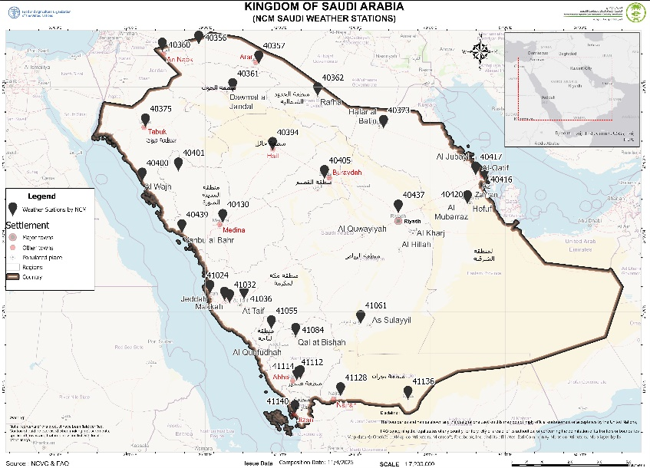

1.02 – Title
Descriptive title for this data. Should provide sufficient information to external users.
Enter Data Title
National Center for Meteorology (NCM) Weather Stations and Monthly Climate Data for Saudi Arabia (1991–2025)

1.03 – Abstract
Provide a short and concise abstract which summarizes what this data is about. Similar to the abstracted provided in a scientific paper.
Enter data abstract
This dataset contains monthly weather observations recorded by the National Center for Meteorology (NCM) across Saudi Arabia from 1991 to 2025. It includes data from synoptic and automatic weather stations that measure rainfall, temperature (maximum, minimum, mean), relative humidity (maximum, minimum, mean), and wind parameters (mean speed and prevailing direction).
Each record includes station name, station number, coordinates, elevation, administrative region, and governorate. The dataset supports climatic analysis, agricultural and environmental monitoring, and validation of satellite-derived products such as CHIRPS rainfall and MODIS land surface temperature.
All stations are geo-referenced in WGS84 and verified through cross-checking with FAO–NCVC and NCM master lists. The dataset enables temporal trend analysis and is essential for long-term climate assessments and land degradation studies under the FAO–NCVC partnership.

1.04 – Date type
Provide all three type of dates - Creation date, Publication date, and Revision date.
Identification of when a given event occurred
Creation | 1991
Publication | 2024
Revision | 2025
relevant date | 2025

1.05 – Group
The group, department or unit to which this data belongs.
Enter group name
Registered Members,
FAO Spatial Data Group,
Natural Resources Management Component NRM - FAO KSA
National Center for Meteorology (NCM), Saudi Arabia

1.06 – Category  Provide one primary category to which this data belong. Select from the list provided. Possible categories related to the SRADP project are highlighted in green color. | 1.07 – Free-text Keywords  Keywords helps Search Engines such as Google find data requested by users. Use FAO AGRIS to select the most appropriate keywords for this data. To make the data discoverable, provide a minimum of 5 keywords.
Field declared Mandatory by the Metadata Schema | A space or comma-separated list of keywords. Use the  Widget to select from Hierarchical tree.
Select one of the following : (highlighted by Yellow) | REQUIRED: Common-use word or phrase used to describe the subject of the data set. (Provide 5 keyword minimum)
Imagery Base Maps Earth Cover | Field survey
Society | Saudi Arabia
Economy | NCM
Utilities Communication | Meteorology
Environment | Weather
Oceans | Stations
Biota | Rainfall
Health | Temperature
Elevation | Humidity
Geoscientific Information | Wind
Planning Cadastre | Climate
Inland Waters | Monitoring
Boundaries | FAO
Structure | NCVC
Transportation | CHIRPS
Intelligence Military | Validation
Location | Land Degradation
Climatology Meteorology Atmosphere | Environmental
Farming | Analysis
Population | Synoptic

Part 2: Location and Licenses (Mandatory)

2.01 Language
Provide data language
Language used within the dataset
Enter data language
English

2.02 License
Provide the type of license under which this data is published and intended to be used.
License of the Dataset
Select one of the following License: (highlighted by Yellow)
NextView
Not Specified
Open Data Commons Open Database License / OSM
Public Domain
Public Domain / USG
Varied / Derived
Varied / Original

2.03 Attribution
Identify the entity or agency with authority and responsibility over this data.
Authority or function assigned, as to a ruler, legislative assembly, delegate, or the like.
*Field declared Mandatory by the Metadata Schema
Enter attribution for this data
Produced by the National Center for Meteorology (NCM) in collaboration with the Food and Agriculture Organization (FAO) of the United Nations and the National Center for Vegetation Cover (NCVC) under the Sustainable Land Management (SLM) Programme. Redistribution or modification requires written authorization from NCM and FAO–NCVC.

2.04 Regions
Identify the region that the data covers. You can provide several regions.
Enter global or specific regions
All 13 administrative regions of Saudi Arabia, including:
Riyadh, Makkah, Madinah, Asir, Al Bahah, Jazan, Tabuk, Hail, Al Jawf, Eastern Province, Northern Border, Najran, and Qassim.

2.05 Data quality statement
Statement on the data quality. This allows any known issue about the data quality to be documented and shared with data user so that they can use the data appropriately.
Provide data quality statement
The dataset was compiled from official NCM archives and validated against field-verified FAO–NCVC station coordinates. Monthly climatic records were checked for consistency, completeness, and plausibility using temporal filters and cross-statistical validation with CHIRPS and ERA5 datasets.
Spatial accuracy is ±0.001° for coordinates, and data completeness exceeds 98% for 1991–2020. Missing values are recorded as NULL.

2.06 Restrictions
Indicate any know restriction on this data. You could consideration the following when assessing data restriction:

(1) Exclusive right to the publication, production, or sale of the rights to a literary, musical, or artistic work, or to the use of a commercial print or label, granted by law for a specified period of time to an author, composer, artist, distribution
(2) Rights to financial benefit from and control of distribution of non-tangible property that is a result of creativity
(3) Formal permission to do something
(4) Government has granted exclusive right to make, sell, use or license an invention or discovery
(5) Produced or sold information awaiting a patent
(6) Withheld from general circulation or disclosure
(7) Name, symbol, or other device identifying a product, officially registered and legally restricted to the use of the owner or manufacturer
(8) Other restrictions
Limitations Placed upon the access or use of the data
* Field declared Mandatory by the Metadata Schema
Enter any know data use restriction information
(3) Formal permission to do something
This data can be used for presentation and View, if there is any kind of modification, coordination with the GIS Department in organization’s office in Saudi Arabia is required.

2.07 Other constraints
Identify any other constrains on this data that would be important to document and share with the data users
Enter other constrains on this data
Historical station identifiers may differ due to NCM network upgrades. Minor coordinate adjustments may exist between legacy and modernized stations.

Part 3: Other Data Description (Optional)

3.01 Edition
If the data is linked or resulting from work that has editions, indicate the edition for this dataset.
Version of the cited resource
Enter Edition
Consolidated NCM Climate Data Series (1991–2025)

3.02 DOI
The DOI (Digital Object Identifier) will be assigned by the Metadata Administrator.
DOI will be added by Admin before publication
Create and enter the data DOI
To be assigned by FAO–NCVC metadata administrator before publication.

3.03 Purpose
The purpose for which this dataset and related studies were undertaken.
Provide data purpose
To provide long-term national climate data for monitoring weather patterns, validating satellite products, and supporting FAO–NCVC studies on drought, land degradation, and agricultural productivity. The dataset is used for trend analysis, climate modeling, and calibration of CHIRPS and NDVI-based indices.

3.04 Maintenance frequency
The frequency for data update.
Frequency with which modifications and deletions are made to the data after it is first produced
Select one of the following : (highlighted by Yellow)
Frequency of maintenance for the data is not known
Data is repeatedly and frequently updated
There are no plans to update the data
Data is updated each day
Data is updated every year
Data is updated as deemed necessary
Data is updated each month
Data is updated every two weeks
Data is updated in intervals that are uneven in duration
Data is updated on weekly basis
Data is updated twice each year
Data is updated every three months

3.05 Spatial representation type

How the spatial data is presented, Method used to represent geographic information in the dataset
Select one of the following : (highlighted by Yellow)
Grid data is used to represent geographic data
Three-dimensional view formed by the intersecting homologous rays of an overlapping pair of image
Textual or tabular data is used to represent the geographic data
Triangulated irregular network
Vector data is used to represent geographic data
Scene from a video recording

3.06 Supplemental information (Remarks)
Provide any additional supplemental information about this data that could help the user when using this data
Enter supplemental information / Remarks
Each station includes monthly observations for multiple parameters:
- Air Temperature (Max, Min, Mean)
- Relative Humidity (Max, Min, Mean)
- Rainfall Total
- Wind Mean Speed
- Wind Prevailing Direction
The dataset covers 86,058 records from 1991–2025. Coordinates are in WGS84 and linked to governorate and regional administrative boundaries. The data is used in multiple FAO analytical workflows including rainfall anomaly analysis, drought indices, and environmental modeling.

3.07 Temporal extent Start and End
Provide temporal extent start and end that may have bearing on this data.
Temporal extent start |  | Temporal extent end
Date | Time | Date | Time
Enter temporal start date | Enter temporal start time | Enter temporal end date | Enter temporal end time
January 1991 |  | December 2025

3.08 Responsible Parties / Point of Contact
Who can be contacted about this data? This is usually the metadata administrator.
Admin Name
Enter Metadata Admin
Dr. Njeru Jeremiah – Chief Technical Advisor of Natural Re Management NRM – FAO KSA
Dr. Ouerchefani, Dalel - TECHNICAL ADVISER, FAOSA
Mr. Gabriel Vincent Sanya - GISRS and Land Cover Mapping Expert -FAOSA
Mr. Haitham Abdullah – GIS Specialist – FAO KSA

3.09 Responsible and Permissions / Owner
Who is the responsible over this data? This is usually the person that led or supported the creation of the data
Data Responsible / Owner
Enter data owner
National Center for Meteorology (NCM)
FAO
NCVC Geo-Spatial Unit
MoEWA

3.10 Metadata Author
Who is the author of the metadata? This is usually the person that led or supported the creation of the data.
Data Responsible / Owner
Enter Metadata Admin
GIS Department in Food and Agriculture Organization of the United Nations (FAO) in Saudi Arabia

Part 4: Part 4 - Data Attributes (Optional)

4.01 Key data features and attributes
Detailed description of the data layer features and attributes will be provide in a separate custom template for data features and attributes description. Here, the key features and attributes (objects) for this data are provided.
Description of key features and attributes
Attribute / Feature | Description
Enter the attributes of this Layer | Enter the description of the attributes
RecID | Unique record identifier
Station_Number | Official NCM station code
Station_Name | Name of the weather station
Elevation | Station elevation (meters above sea level)
Latitude | Latitude in decimal degrees (WGS84)
Longitude | Longitude in decimal degrees (WGS84)
Region | Administrative region of Saudi Arabia
Governorate | Local administrative area
Year | Year of observation
Month | Month of observation
Parameter | Climatic variable (e.g., Rainfall, Air Temperature Max, Min, Mean, Relative Humidity, Wind)
Value | Observed monthly value
Remarks | Notes or NULL where no observation was recorded
Data_Source | National Center for Meteorology (NCM), Saudi Arabia
Update_Frequency | Annual

